Lab #1: Lab 1: Loan Calculator (Recursion)

*Carson Kramer*

*January 30th, 2023*

ALGORITHM

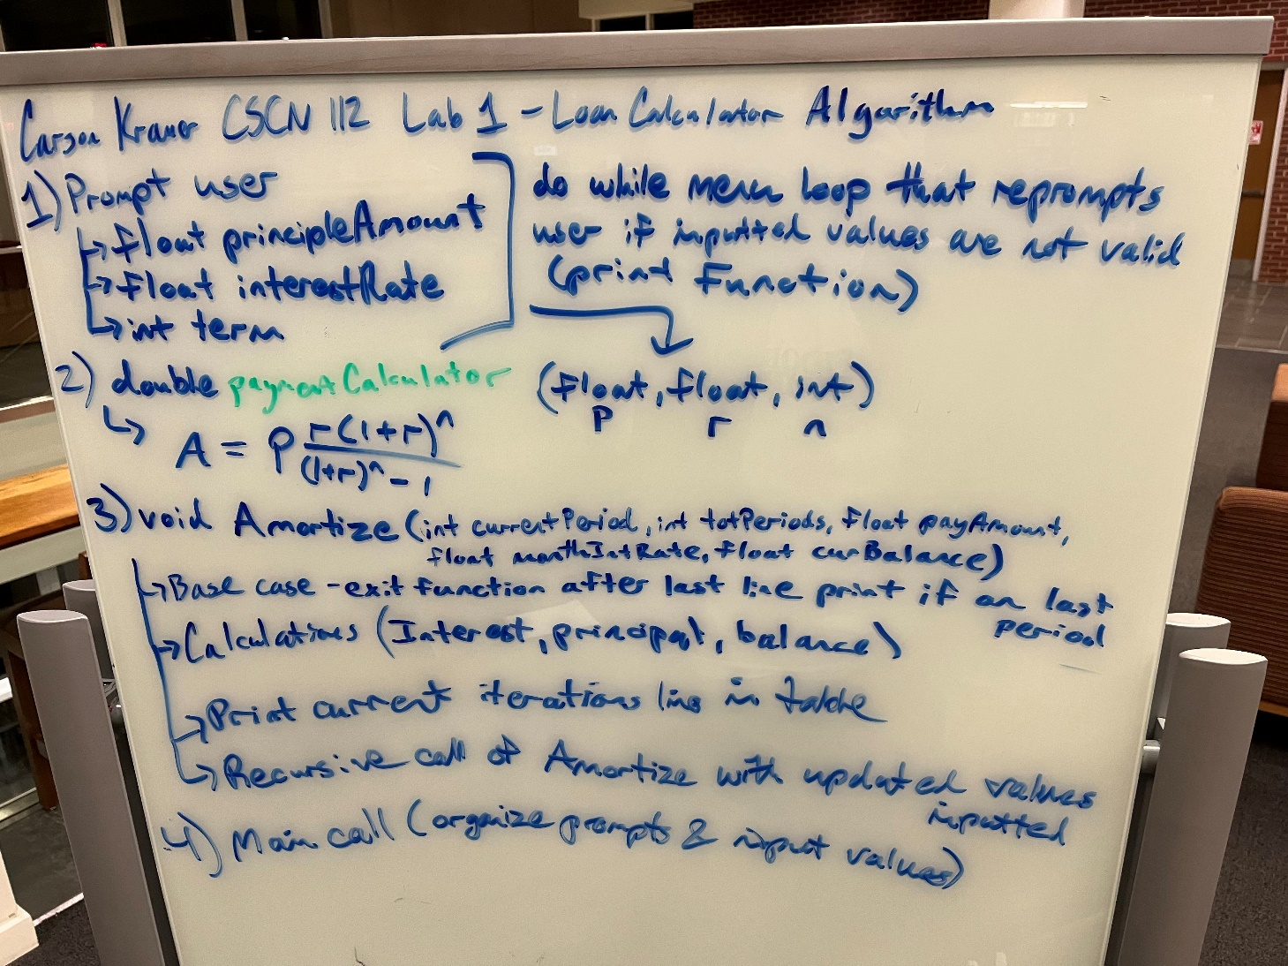

**NOTE: Changed floats to doubles due to rounding issues, and had to adjust paymentCalculator values before entering into equation**

SCREEN-SHOTS OF RUNNING PROGRAM

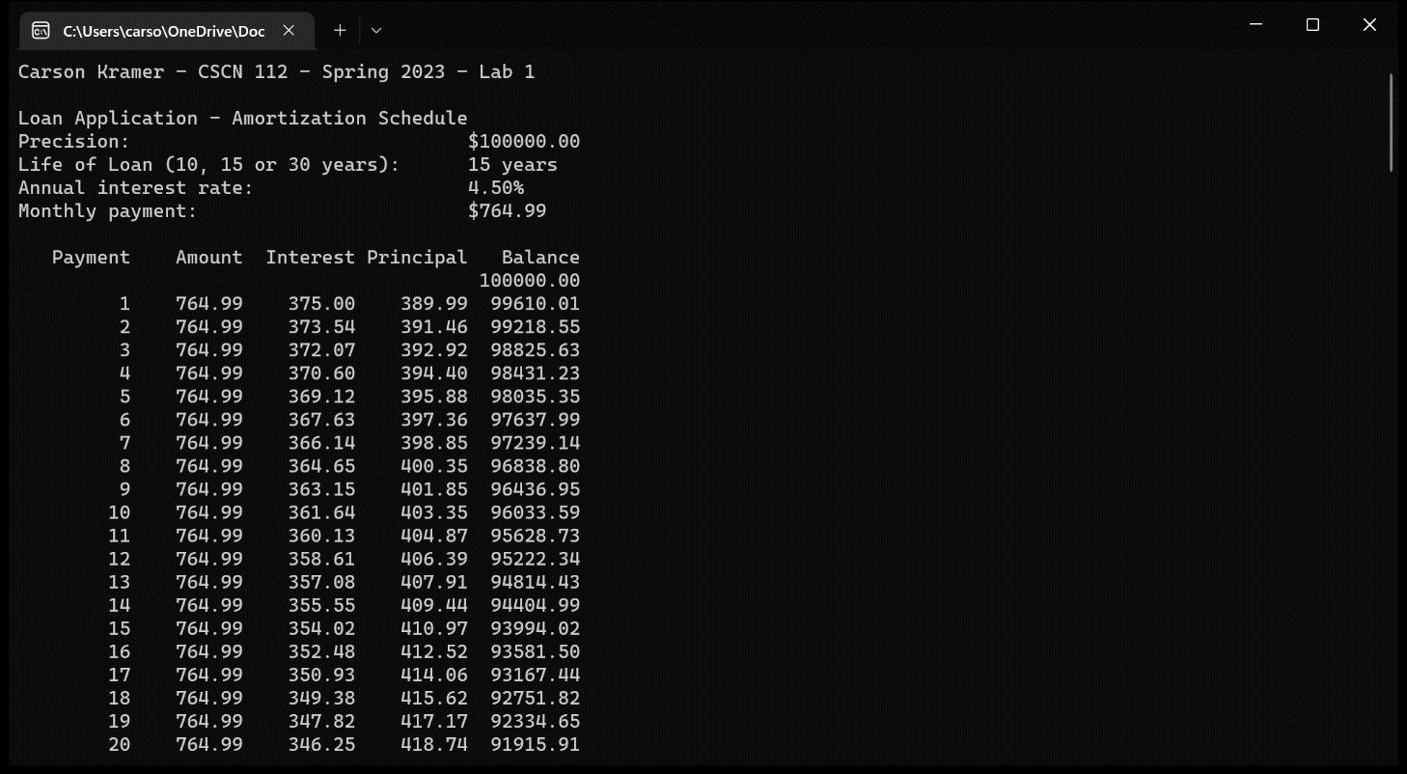

INTEGRITY STATEMENTS

* I have not shared the source code in my program with anyone other than the pre-approved human sources.
  + *Please include a note here if you have used one or more of the pre-approved human sources or received special permission from me.*
* I have not used source code obtained from another student, or any other unauthorized source, either modified or unmodified.
* If any source code or documentation used in my program was obtained from another source, such as the course textbook or course notes, that has been clearly noted with a proper citation in the comments of my program.
  + It would also be helpful to include a note here of which sources you used
* I have not knowingly designed this program in such a way as to defeat or interfere with the normal operation of any machine it is graded on or to produce apparently correct results when in fact it does not.

Note: These statements serve as your personal promise that the above is true. If I find that you have not been true to ALL of the four statements above, you will get a zero for the assignment and receive an academic violation report (which goes on your academic record). Both are minor compared to the loss of your integrity.